

**UNIVERSITY OF THE WITWATERSRAND, JOHANNESBURG**

**SCHOOL OF CLINICAL MEDICINE**

**ADDENDUM TO APPLICATION FORM FOR BHSc HONOURS IN HEALTH SYSTEMS SCIENCE**

Dear Applicant,

Please provide us with a **full curriculum vitae** and the following information to assist us in the selection of applicants.

**NAME: Date of birth:**

Please mark the programme for which you are applying:

|  |  |
| --- | --- |
| The **BHSc Honours in Health Systems Science** have 4 streams on offer and these are indicated below. Please indicate your first, second and third choices, if you have more than one choice. | |
| **Health Administration** |  |
| **Health Analytics** |  |
| **Health Entrepreneurship** |  |
| **Health Systems Research** |  |

**2. Motivation Letter Guidelines**

Please write a motivation letter (this should not be handwritten) outlining your reasons for applying to the program and specifically to the field of study for which you are applying. The letter should reflect your understanding of Health Systems Science and the relevant field of study.

In your motivation, please include how you believe this program and field of study will enhance your current or future career goals. Additionally, highlight the knowledge and experience you possess that will contribute to shared learning within the program, and articulate why you should be considered for admission.

Your motivation letter should not exceed two typed pages, with 1.5 line spacing. If you are applying for more than one stream, please ensure that your motivation addresses each stream accordingly.

|  |
| --- |
| Insert your motivation here: |

**4. Problem Statement Guidelines**

Please write a clear and compelling problem statement within the context of Health Systems Science. Considering the building blocks of the Health System (Figure 1 below) identify a specific issue within one of the building blocks, provide a rationale for why it is a problem, draw on relevant literature to support your claims, and conclude with a potential research question.

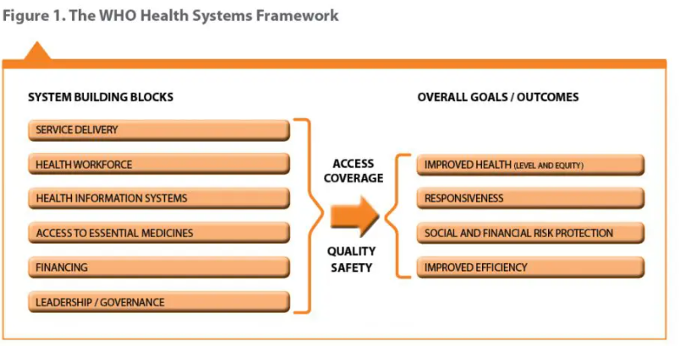

*Figure 1 Source: Monitoring the building blocks of health systems: a handbook of indicators and their measurement strategies. Geneva: World Health Organization; 2010*

Clearly identify and articulate a problem within one of the building blocks of the health system and specify why this problem is significant and relevant in the current health system of South Africa

Draw on relevant literature to support your claims, by conducting a concise literature review citing scholarly articles and, reports,

Ensure that your problem statement is well-organized, clear, and logically structured.

Conclude your problem statement with a well-formulated research question that encapsulates the essence of the issue identified. You do not need to include your methodology as this will be developed in the honours programme.

Please note that the main aim of this activity is to see your ability to build an academic argument. Therefore, you will not be tied to this research problem as you will develop your research focus during the research methodology course.

|  |
| --- |
| Insert your problem statement here: |

**5. This is a blended learning programme with 70% of the course being taught online. Do you have:**

|  |  |
| --- | --- |
|  | Indicate your experience |
| Experience with an LMS?   * Canvas * Moodle * Blackboard etc. |  |
| Experience with blended learning? |  |
| Experience with self-directed learning including time management? |  |
| Experience with team-based learning? |  |
| Experience with multiple learning technologies? (This course uses multiple technologies such as MIro, Padlet, the LMS, Yammer and many more |  |
| Do you have a dedicated laptop or computer that you can use for this programme? |  |
| Do you have internet access to be able to complete the programme? (you can work on campus) |  |

**6. Which of the following data analysis and referencing software are you familiar with:**

|  |  |
| --- | --- |
|  | Indicate your experience |
| STATA |  |
| SPSS |  |
| NViVO |  |
| Atlas ti |  |
| MAXQDA |  |
| EndNote / Zotero |  |
| Mendeley |  |
| Other |  |

**7 For data science do you have any experience with programming (if yes please list your experience with different programming languages and your level**

|  |
| --- |
| Indicate your experience here: |

**8. Do you have a portfolio of learning Yes / No**

|  |
| --- |
| If yes, please include your link here: |

**9. What are your e-mail addresses:**

|  |
| --- |
| Please include here: |

**10. References**

Please arrange for two reference reports from academic referees, using the template available on the website. Your referees should be able to attest to your academic abilities and preparedness for a postgraduate degree. References from family friends or other community members are not acceptable.

It is imperative that all supporting documents—including your Degree, Academic Record/Transcript, Curriculum Vitae, Motivation Letter, References, and SAQA documentation for International Students—are uploaded to Wits Self Services before the closing date. This is necessary for the selection committee to effectively review your application.

**11. Academic Transcripts and Certificates**

Please add all your degrees, Academic Record/Transcripts and a SAQA certificate for international students here. Please also upload any additional supporting documents.

|  |
| --- |
| Add your transcripts and certificates here: |

*We appreciate your completing this form*